UNITED STATES

SECURITIES AND EXCHANGE COMMISSION
Washington, D.C. 20549

SCHEDULE 14A

Proxy Statement Pursuant to Section 14(a) of the

Securities Exchange Act of 1934

Filed by the Registrant ☒ Filed by a Party other than the Registrant ☐

Check the appropriate box:

- Preliminary Proxy Statement

- Confidential, for Use of the Commission Only (as permitted by Rule 14a-6(e)(2))

- Definitive Proxy Statement

- Definitive Additional Materials

- Soliciting Material under §240.14a-12

Pitney Bowes Inc.

(Name of Registrant as Specified In Its Charter)

(Name of Person(s) Filing Proxy Statement, if other than the Registrant)

Payment of Filing Fee (Check all boxes that apply):

- No fee required

- Fee paid previously with preliminary materials

- Fee computed on table in exhibit required by Item 25(b) per Exchange Act Rules 14a-6(i)(1) and 0-11

On April 6, 2023, Pitney Bowes Inc. (the “Company”) issued the following press release in connection with the Company’s 2023 annual meeting of shareholders (the “Annual Meeting”), which contains a copy of a letter to shareholders issued by the Company’s Board of Directors. A copy of the press release and letter can be found below:

Pitney Bowes Board of Directors Issues Letter to Shareholders

Company Recently Refreshed the Board, Appointing Two Highly Qualified and Experienced Directors in

Addition to Recommending Hestia Nominee Katie May

Pitney Bowes Nominees Outmatch Hestia’s Slate in Relevant Experience and Skill Sets

Hestia Nominee Lance Rosenzweig Unqualified as a Director or as CEO

Urges Shareholders Vote FOR Pitney Bowes’ Nominees and Katie May on the GOLD Proxy Card

STAMFORD, Conn., April 6, 2023 – Pitney Bowes (the “Company”) (NYSE:PBI), a global shipping and mailing company that provides technology, logistics, and financial services, today issued a letter to Pitney Bowes shareholders in connection with the Company’s 2023 Annual Meeting of Shareholders (the “Annual Meeting”) to be held on May 9, 2023.

At the Annual Meeting, activist investor Hestia Capital Management, LLC (“Hestia”) is seeking to replace four of Pitney Bowes’ highly qualified directors with its own candidates, including its own founder, Kurt Wolf, and install one of its unqualified nominees, Lance Rosenzweig, as CEO of the Company. Pitney Bowes urges shareholders to vote FOR all Pitney Bowes nominees and Hestia nominee Katie May on the GOLD proxy card. Over the past five years, Pitney Bowes has implemented numerous changes to ensure its current Board is comprised of a strong, engaged, and diverse set of directors, with a balanced mix of experience, skills, leadership expertise, and new perspectives. This includes adding six new independent directors and announcing the departure of eight longer tenured directors since 2018, illustrating the Company’s commitment to regular and ongoing Board refreshment, assuming the election of Katie May. Hestia refuses to acknowledge these rigorous and positive changes and is instead seeking to destabilize the Board, impede our strategic progress, and put shareholder value at risk. Under their proposal, the Board would have seven new directors out of nine to join the Board in 2023, in addition to four new committee chairs, a new Chairman, and a new unqualified CEO. This would mean that the Pitney Bowes Board would have an average tenure of approximately 0.9 years and potentially little to no understanding of the Company’s strategy, our transformation, and our business. Pitney Bowes’ recommended nominees are the right individuals to drive the Company forward, ensure the long-term success of the businesses, and enhance value for shareholders.

It is apparent that, despite claiming to have a qualified interim CEO candidate since December 2022, Hestia has not been able to present one. Instead, Hestia defaulted to one of its previously named director nominees as a last resort when it disclosed Lance Rosenzweig as its CEO candidate earlier this week. To be clear, the Board does not believe that Mr. Rosenzweig is qualified to serve as a director of Pitney Bowes, much less as CEO, based on his history of poor performance and weak corporate governance track record, as well as his lack of shipping and logistics experience. The Board remains committed to Marc Lautenbach as CEO to realize the benefits of the Company transformation that they have overseen over the last ten years to position the business for long-term success and subsequently deliver significant value to shareholders.

Further, Hestia’s ever-changing strategies continue to demonstrate a fundamental misunderstanding of Pitney Bowes. Below are but a few false narratives and unviable strategies Hestia promoted in its most recent communications on April 4, 2023.

- GEC: Hestia fails to understand the path to profitable growth and instead believes that a strategy of shrinking to become some unidentified “niche” provider will benefit shareholders.

- SendTech: Hestia fails to understand the productive investments we have made to refresh products, integrate shipping software and introduce SaaS offerings that are now driving growth.

- Presort: Hestia mentions an undefined “strategy” for alternative pricing and disregards the accretive 12 tuck-in acquisitions Pitney Bowes has made over the last several years.

- Corporate Expenses: Hestia disregards that Pitney Bowes has eliminated several hundred million dollars of expenses and the rationale for maintaining expenses that benefit the business units at the corporate level.

- Balance Sheet: Hestia tries to create a false narrative around debt maturities when we have less than $240mm of maturities until March 2026.

The transformation of Pitney Bowes will be sustained by the strategic direction of GEC and the continued investment in SendTech and Presort, while maintaining a stable capital structure. Hestia’s slate has no public company shipping and logistics experience. To augment the shipping and logistics experience our board already had, we have added Steve Brill who had an impeccable, thirty-year career at UPS. Aside from the significant under-qualifications of the Hestia slate, the directors they have recommended are more appropriate for to leading small, technology based start-up enterprises, not a multi-billion dollar enterprise with large clients, significant partnerships like the one with the United States Postal Service and synergistic business segments.

All Pitney Bowes shareholders of record as of the close of business on March 10, 2023 are entitled to vote in connection with the Annual Meeting. For more information about the Annual Meeting, please visit: www.VoteforPitneyBowes.com

The full text of the letter follows.

Dear Fellow Shareholder,

Your vote at Pitney Bowes’ Annual Meeting on May 9, 2023, is critical to the future of our Company. As you may know, Hestia is seeking control of our Board and to remove Marc Lautenbach as our CEO. Your Board and the management team led by Marc Lautenbach have taken decisive actions to implement a

comprehensive transformation of the Company and refresh your Board’s composition to drive improved financial performance – delivering improved, measurable results and positioning the Company to drive shareholder value. We urge you to protect the value of your investment and support your Board by voting the GOLD proxy card today “FOR” all Pitney Bowes nominees and Hestia nominee Katie May.

We have sought in earnest to work with Hestia over many months to avoid a costly and distracting proxy fight. However, Hestia has instead proceeded to propose a wide range of inconsistent and ever-changing strategies, including how it would change our Board, CEO, the GEC business, and capital allocation strategy. Hestia’s erratic ‘flip-flopping’ has made it impossible for Pitney Bowes and Hestia to reach an amicable resolution and proves that it has an incoherent, half-baked vision for how it would run the Company and oversee your investment.

We constantly engaged with Hestia and have sought an amicable resolution, including offering to work with them to appoint three new directors to the Board. With our recent Board refreshment, we will have now essentially already done this through the appointments of Darrell Thomas and Steven D. Brill to the Board, along with our recommendation of Katie May for election at the Annual Meeting. Additionally, Bob Dutkowsky has succeeded Michael Roth as our Non-Executive Chair.

Furthermore, it is clear that many months after its December announcement to search for a CEO candidate, Hestia has failed to find a qualified individual and instead defaulted to one of its previously named director nominees as a last resort. As we’ve already stated, the Board does not believe that Lance Rosenzweig is qualified to serve as a director of Pitney Bowes, much less as CEO, based on his history of poor performance, weak corporate governance track record, as well as his lack of shipping and logistics experience. The Board remains committed to Marc Lautenbach to realize the benefits of the Company transformation that he has overseen over the last ten years to position the business for long-term success and subsequently deliver significant value to our shareholders.

Pitney Bowes has already implemented significant changes to the Board. Our recommended nominees are the right individuals to drive Pitney Bowes forward, ensure the long-term success of our businesses, and enhance value for shareholders.

The Pitney Bowes Board is comprised of a strong, engaged, and diverse set of directors, with a balanced mix of experience, skills, leadership expertise, and new perspectives. In line with our commitment to regular and ongoing Board refreshment, we recently refreshed our Board by appointing Darrell Thomas and Steven D. Brill to the Board, supporting the election of Hestia nominee Katie May at the upcoming Annual Meeting, electing Robert M. Dutkowsky as Non-Executive Chair of the Board, and announcing that Michael I. Roth, S. Douglas Hutcheson, and David L. Shedlarz will not stand for re-election at the Annual Meeting. These changes were in addition to the three new independent directors who joined the Board between 2018 and 2022, as well as the three committee chairmanships we changed in the last few years. If our recommended director nominees are elected, our Board will be

88.9% independent and 66.7% diverse, with an average tenure of approximately 5.1 years. In addition, six new independent directors will have joined the Pitney Bowes Board and eight longer tenured directors will have departed since 2018, assuming the election of Katie May.

Conversely, if Hestia is successful in electing all of its nominees to the Board, the average tenure on the Board would be approximately 0.9 years. We believe that if any of Hestia’s nominees beyond Katie May were to be elected at the Annual Meeting, and the Board members that Hestia seeks to replace – Anne Busquet, Bob Dutkowsky, Marc Lautenbach, and Linda Sanford – are not re-elected, then the Pitney Bowes would cease to have the right balance of new and more tenured directors, thus destabilizing the Board and putting long term shareholder value at significant risk. In addition, such a Board would only have 11.6 years of average public company board experience compared to Pitney Bowes’ Board with 24.9 years of average public company board experience per director. Hestia’s proposed Board possess no institutional knowledge of our business, in turn creating significant risk for our Company and shareholders.
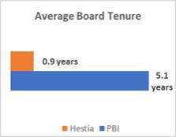

We have always sought a proper balance of directors with institutional and industry knowledge, as well as newer voices with fresh viewpoints on the Company, and the changes we have made since 2018 clearly reflect this commitment. We firmly believe that our recommended nominees are the right individuals to drive Pitney Bowes forward, ensure the long-term success of our businesses, and enhance value for shareholders.

Finally, we have received recognition for our sound corporate governance practices from third parties such as Institutional Shareholder Services (“ISS”), which has given Pitney Bowes its best rating for low risk in corporate governance, even before the changes we made earlier this year.

Robert M. (“Bob”) Dutkowsky


Former Executive Chair, Tech Data

Director since: 2018

Pitney Bowes Director Nominees

Mr. Dutkowsky is the Non-Executive Chair of the Board and has been a steadfast strategic and commercial leader on the Board since 2018, helping drive our strategic Company transformation.

Key Experience/Qualifications:

✓ Expertise developed as the Chair and CEO of several supply chain companies in other industries, including one of the world’s largest, allowing him to provide an invaluable perspective to Pitney Bowes related to finance, management, operations, and risk.

✓ Possesses broad global business, industry, and operational experience and is highly skilled at viewing the technology industry from a variety of perspectives.

✓ Extensive corporate governance expertise, having served on nine public company boards throughout his career.

✓ Served as the Chair of five public companies and CEO of three.

Other Affiliation(s):

• US Foods (Non-Executive Chair of the Board)

• Raymond James Financial (Director)

• The Hershey Company (Director)



Marc B. Lautenbach

President & CEO, Pitney Bowes

Director since: 2012

Mr. Lautenbach possesses substantial operational experience, including in technology services, software solutions, application development, and infrastructure management, as well as marketing, sales, and product development. His leadership is crucial to our future success.

Key Experience/Qualifications:

✓ Extensive experience working with a breadth of client segments, including the small- and medium

-sized business segment and public and enterprise markets, and possesses significant international experience.

✓ Overseen the Company’s strategic transformation and taken decisive action to create long-term value for shareholders in an unpredictable and volatile market. Taken decisive actions to create long-term value for shareholders by transforming the Company from a position of secular decline to growth.

✓ Worked with our Board and management team over the past 10 years to reduce our debt by $1.7 billion, eliminate several hundred million dollars of expenses, return $1.5 billion in capital to shareholders in the form of dividends and share repurchases, and divest $2.1 billion of non-core, slower-growth businesses.

✓ Improved the Company’s revenue CAGR from -8.6% from 2007 – 2012, the years prior to Mr. Lautenbach joining the Company, to 4.9% from 2017 – 2022.

Other Affiliation(s):

• Campbell Soup Company (Director)

Steven D. Brill


Retired, UPS Executive

Director since: 2023

Mr. Brill has had a successful career in logistics, operations, marketing, sales, and strategy, positioning him as an industry expert and a valued member of our refreshed Board. He brings deep expertise in the nuances of the logistics industry.

Key Experience/Qualifications:

✓ Retired from UPS in 2020, where he last served as the President of Corporate Strategy, working on the long-term direction of the enterprise to drive sustainable profitable growth. This included developing strategic imperatives as well as organic and M&A strategies across global markets, business units, and verticals.

✓ Over 33 years experience in logistics and e-Commerce, serving in a variety of transformational leadership roles

at UPS, including the head of a $4 billion cost reduction program that funded the company’s investment in healthcare, eCommerce, small & medium size business and international expansion.

✓ Prior to this, he served as the Vice President of Global Retail and B2C strategy, where he led the organization’s transition to a majority eCommerce provider and positioned UPS for growth in the rapidly evolving retail and consumer goods marketplace.

✓ UPS career included various leadership positions in logistics, operations, marketing, sales, and strategy.



Anne M. Busquet

Principal, AMB Advisors, LLC

Director since: 2007


Mary J. Steele Guilfoile

Chair, MG Advisors, Inc.

Director since: 2018

Ms. Busquet is a proven business leader with a long track record of success and has been a crucial member of the Pitney Bowes Board. She has led the Governance Committee’s efforts to refresh our Board in recent years.

Key Experience/Qualifications:

✓ 30 years of experience as a senior public company executive in interactive service initiatives, financial services, digital and business development, and marketing at leading companies, including American Express and InterActive Corp.

✓ Recognized for her substantial operational experience, including in international markets, marketing channels, emerging technologies and services, and product development.

✓ Served on eight public company boards throughout her career.

Other Affiliation(s):

• CareCloud (formerly Medical Transcription Billing Corp.) (Director)

• Elior Group (Director)

Ms. Guilfoile brings vital knowledge and expertise as a financial industry executive as well as training as a certified public accountant.

Key Experience/Qualifications:

✓ Financial Services executive for 25 years on Wall Street, including at JP Morgan Chase, and other financial services firms. Has relevant industry experience, serving on the Board of C.H. Robinson Worldwide, a logistics company, since 2012.

✓ Gained expertise through positions as treasurer, CFO, COO, Chief of Strategy, and as a private placement deal person. Possesses valuable expertise and know-how in areas including accounting, risk management, and auditing, and has worked in various merger integration, executive management, and strategic planning positions.

✓ Extensive experience serving on Board Audit Committees, including for Pitney Bowes. Mary also serves as Chair of the Audit Committee for The Interpublic Group of Companies and DUFRY AG, respectively, and is a CPA – which she continues to maintain.

✓ Served on a total of seven public company boards throughout her career.

Other Affiliation(s):

• The Interpublic Group of Companies, Inc. (Director)

• C.H. Robinson Worldwide (Director)

• DUFRY AG (Director)



Linda S. Sanford

Retired Senior Vice President, Enterprise Transformation, IBM

Director since: 2015

Ms. Sanford brings a wide range of expertise to the Board and has immense knowledge as a senior executive in a public global technology company. She leads our Compensation Committee’s efforts to ensure Pitney Bowes has metrics in place that foster a pay for performance culture.

Key Experience/Qualifications:

✓ Retired Senior Vice President of Enterprise Transformation at IBM, where she was responsible for working across IBM to transform core business processes and create an IT infrastructure to support and integrate processes globally.

✓ Possesses a deep understanding of technology and global operations and is a member of the Women in Technology International Hall of Fame and the National Academy of Engineering.

✓ Led the transformation of a highly-visible business that is still growing (at IBM) and has deep operational experience transforming and leading businesses.

✓ Served on five public company boards throughout her career.

Other Affiliation(s):

• Consolidated Edison, Inc. (Director)

• The Interpublic Group of Companies, Inc. (Director)

Sheila A. Stamps


Former Financial Services Executive

Director since: 2020

Ms. Stamps brings experience as a senior banking executive at Bank of America and other financial services firms and an investor perspective as former head of fixed income at New York State Common Retirement Fund. She has served extensively on numerous public company boards and the Pitney Bowes Board regularly leverages her deep expertise to ensure best-in-class corporate governance practices.

Key Experience/Qualifications:

✓ Operating experience in commercial banking and capital markets, small and medium sized businesses, risk management, and international markets.

✓ Extensive knowledge from diverse roles in logistics, regulatory and government affairs, business transformation, and corporate governance.

✓ Served on five public company boards throughout her career and has over 12 years of Governance experience. This includes serving as the Chair of the Finance and Audit Committee of Atlas Air’s Board of Directors, as well as on Nominating/Governance, Compensation, Risk and Audit and Finance committees of boards.

Other Affiliation(s):

• MFA Financial Inc. (Director)

• IQVIA Holdings Inc. (Director)



Darrell Thomas

Retired Vice President and Treasurer for Harley-Davidson, Inc.

Director since: 2023

Mr. Thomas brings a wealth of valuable experience to the Board, particularly in finance and treasury, and most recently served as Vice President and Treasurer for Harley-Davidson, Inc. Like Pitney Bowes Bank, Harley-Davidson owns an industrial loan corporation bank.

Key Experience/Qualifications:

✓ Spent nearly two decades working in banking with Commerzbank Securities, Swiss Re New Markets, ABN Amro Bank, and Citicorp/Citibank, where he held various capital markets and corporate finance roles.

✓ Significant board experience, including on the boards of British American Tobacco, Dorman Products, Scotia Holdings (US), and Sojourner Family Peace Center.

✓ Served as Vice President and Interim CFO of Harley-Davidson, Inc., having previously held several senior finance positions including Treasurer.

✓ Possesses deep understanding of capital allocation, liquidity, and risk management.

Other Affiliation(s):

• Scotia Holdings, Inc. (Director)

• Dorman Products (Director)

• British American Tobacco p.l.c. (Director)

We also recommend shareholders vote for one of Hestia’s nominees, Katie May, as we believe her experience and background will be valuable to the Board.

Katie May


Former CEO, ShippingEasy.com

Ms. May has relevant industry experience and entrepreneurial qualities that make her a key candidate for our Board.

Key Experience/Qualifications:

✓ Led ShippingEasy.com, before it was acquired by Stamps.com, as Chief Executive Officer. Ms. May served on Stamps.com’s Board for over two years.

✓ Founded Kidspot.com.au, where she served as Chief Executive Officer and Executive Director from 2005-2011 until its sale to News Corp.

✓ Served in a variety of marketing and financial roles at Arthur Anderson, Philip Morris, and Booz & Company.

Other Affiliation(s):

• Rokt (Director)

• Thinkific (Director)

• Onramp, Inc (Director)

• Vivi (Director)

• Buildxact (Director)

In sharp contrast, we believe the rest of Hestia’s nominees lack the necessary experience and skills to execute Pitney Bowes’ strategy and enhance long-term value for shareholders and would be detrimental to the success of the Company.

In addition to putting out false and misleading information regarding Pitney Bowes, our Board, and management team, Hestia has attempted to grossly exaggerate the relevant experience of its nominees. Upon closer review, it becomes clear that the majority of experience that Hestia cites¹ for its director
- Hestia Letter to Pitney Bowes Shareholders, March 16, 2023.

nominees is either superficial or not in any way relevant to Pitney Bowes. Furthermore, the fact that Hestia is proposing director nominees to be in charge of different parts of Pitney Bowes business – as opposed to management oversight – is directly against how a public company board should operate and confirms our view that their proposed CEO, Lance Rosenzweig, is unqualified for the role.

Hestia Nominee

Lance Rosenzweig has a checkered past involving extensive management disputes – like his issues while on the board of NextGen Healthcare – and poor performance. He is unqualified to serve as CEO based on his history of poor performance, a weak track record on corporate governance, as well as his lack of shipping and logistics experience.

Kurt Wolf lacks the relevant qualifications and background to be additive to the Pitney Bowes Board. His unpredictable and erratic behavior over the course of many months of engagement between the Company and Hestia calls into question his commitment to creating shareholder value and the execution of our strategy for the benefit of ALL shareholders.

Milena Alberti-Perez falls short of the experience needed to be on the Board of Pitney Bowes.

Qualities Detrimental to Pitney Bowes

× Mr. Rosenzweig lacks shipping and logistics experience.

× While at NextGen Healthcare, Mr. Rosenzweig oversaw poor financial results, consistently trailing its peers.

The company faced two different, significant lawsuits for disseminating misleading information to investors.

× He also subjected the NextGen Healthcare board to multiple U-turns concerning his running for re-election as

a director. When he eventually ran for election at NextGen Healthcare’s 2021 annual meeting, he had the support of just one other director and was not re-elected by the company’s shareholders.

× While at Support.com, Mr. Rosenzweig had a mixed track record: he fired the CEO shortly after he proposed significant restructuring and cost-cutting measures, including cuts to Mr. Rosenzweig’s compensation.

× Mr. Wolf lacks shipping and logistics or other operational experience and has limited public company board experience, having resigned from GameStop’s Board after not even a year and Edgewater Technology’s Board after just over a year and a half, and currently serving on no public company board.

× His abrupt departure from the GameStop Board, which was seemingly due to discontentment from his investors, is deeply concerning, as any nominee to the Pitney Bowes Board must be committed to overseeing strategic change at Pitney Bowes and creating long-term value for all Pitney Bowes shareholders, not just the short-term investors who have invested with Mr. Wolf’s fund.

× As noted in Hestia’s letter to Pitney Bowes shareholders on March 16, 2023, “the majority [of Mr. Wolf’s] personal worth” is invested in Pitney Bowes. This calls into question whether Mr. Wolf’s own personal financial circumstances and interests could lead to conflicts of interest or short-sightedness.

× Ms. Alberti-Perez lacks shipping and logistics experience.

× Ms. Alberti-Perez received her first appointment to the board of a public company less than a year ago when she joined Digimarc Corporation, a provider of enterprise software and services whose market capitalization is approximately half of that of Pitney Bowes.

× Hestia tries to obscure the fact that Ms. Alberti-Perez has never served as CFO of a publicly traded company. Hestia’s January 23, 2023, press release misleadingly implied that Ms. Alberti-Perez has experience as a CFO of a public company due to her time spent at Getty Images Inc.

× In fact, Ms. Alberti-Perez departed from Getty Images Inc. in January 2022, several months before the closing of the SPAC merger that took the company public in July 2022.

Hestia Nominee

Todd Everett has limited qualifications, having spent most of his career at the small-scale Newgistics before it was acquired by Pitney Bowes.

Qualities Detrimental to Pitney Bowes

× Mr. Everett has never served as a director of a publicly traded company.

× He was CEO of Newgistics for only 18 months, during a time when the business was much smaller and less technologically and nationally focused than it is today.

× In addition, the differences in strategic direction and scale between Newgistics and Pitney Bowes are stark, raising questions about what applicable experience Mr. Everett truly has.

× There are some serious potential competition concerns related to Mr. Everett’s service on the boards of certain private companies, including ACI Group and Doddle Parcel Services.

× It is also troubling that Hestia touts Mr. Everett’s reputation as a strategic advisor, despite his track record of advising only small, sometimes unsuccessful startups.

Pitney Bowes remains open-minded to constructive ideas, from any source, that will drive shareholder value. However, your Board believes it is not in shareholders’ best interest to bring Hestia’s haphazard, poorly conceived, and value-destroying ideas into the boardroom.

Unfortunately, Hestia has continued to change its demands and has yet to fully articulate an actionable, specific long-term strategy or plan for the Company, despite claiming for the last four months to have a 100-day plan. Instead, their recent shareholder letter contains nothing new of strategic value to Pitney Bowes. It provides only vague, superficial ideas on change as opposed to precise and actionable ideas. Further, Hestia misrepresents the qualifications of Hestia’s director nominees and their ability to drive meaningful change in any of the strategic categories that Hestia claims it would oversee. Our March 27 letter to shareholders describes in greater detail the various inaccurate claims made by Hestia, including false narratives as it pertains to our overall strategy, capital allocation and debt, GEC strategy, competitors, M&A approach, shareholder engagement, and executive compensation.

Further, Hestia brazenly violated the federal proxy rules when it boldly announced a “$15+” price target for Pitney Bowes stock because it is considered misleading to make “[p]redictions as to specific future market values” in a proxy contest.² Clearly, the Pitney Bowes Board and management team have a view as to the potential future share price of the stock; however, unlike Hestia we will play by the rules. Given Hestia’s lack of a coherent or strategic go-forward plan, as well as the changes we have already made to the Board, coupled with our recommendation of one of Hestia’s recommended nominees, we firmly believe that it would be irresponsible to elect ANY of Hestia’s proposed directors, other than Katie May, at this point. Further change would be unnecessary and destabilizing to the Company and the Board. This is even more true in light of how unqualified Hestia’s other director nominees are.

- Rule 14a-9(a), Note a. under the Securities and Exchange Act of 1934.

VOTE THE GOLD PROXY CARD TODAY FOR PITNEY BOWES’ NOMINEES AND KATIE MAY

The Board urges all shareholders to protect the value of your investment and vote “FOR” all the nominees recommended by the Pitney Bowes Board (all eight Company nominees and Hestia nominee, Katie May) on the GOLD proxy card today.

All Pitney Bowes shareholders of record as of the close of business on March 10, 2023 are entitled to vote in connection with the Annual Meeting.

Please vote using one of the following methods:

Vote Online

Go to the website identified on the enclosed GOLD proxy card or voting instruction form.

Vote by Mail

If you received your Annual Meeting material by mail, you also may choose to grant your proxy by completing, signing, dating, and returning the enclosed GOLD proxy card.

We encourage shareholders to disregard any white proxy card or other solicitation materials sent to you by Hestia. Only your latest dated proxy card will be counted at the Annual Meeting.

For more information, please visit the Pitney Bowes Annual Meeting website at www.VoteforPitneyBowes.com. Shareholders who have any questions or need assistance voting may contact the Company’s proxy solicitor, Morrow Sodali LLC, toll-free at 1 (800) 662-5200.

Thank you for your continued support of Pitney Bowes.

Sincerely,

The Pitney Bowes Board of Directors

Also in connection with the Company’s Annual Meeting, the Company issued a letter to its employees. A copy of the letter can be found below:

Today, the Board of Directors issued a letter to shareholders in connection with the Company’s 2023 Annual Meeting to be held on May 9, 2023. In the letter, we outline the reasons why shareholders should vote FOR all of Pitney Bowes’ Board nominees, as well as Katie May, and provided additional context behind these recommendations, the unique qualifications and expertise of our director nominees, and the Board’s support of Marc Lautenbach as CEO.

For the important facts about our performance, Board of Directors, commitment to shareholders, capital allocation history, and other important aspects of our business, please refer to www.voteforpitneybowes.com.

If you are a shareholder of Pitney Bowes, you can also find important information on how to vote on this website. Your Board of Directors recommends that you vote on the GOLD proxy card “FOR” all Pitney Bowes nominees as well as Hestia nominee Katie May. In addition, some of you who hold shares of Pitney Bowes stock may have recently received a letter and materials from them in connection with the Annual Meeting – we advise you disregard and discard of any materials sent to you by Hestia.

If you are contacted by the media, please direct them to Bill Hughes, Chief Communications Officer at William.Hughes@pb.com. If you are contacted by an investor, please direct them to Ned Zachar, Vice President, Investor Relations at Ned.Zachar@pb.com.

Also in connection with the Annual Meeting, the Company posted the following on LinkedIn on April 6, 2023:

Our Board is comprised of the right individuals to drive Pitney Bowes forward, ensure the long-term success of our business, and create value for shareholders. Learn more about our leadership & vision for the future. bit.ly/3ZNVzKG

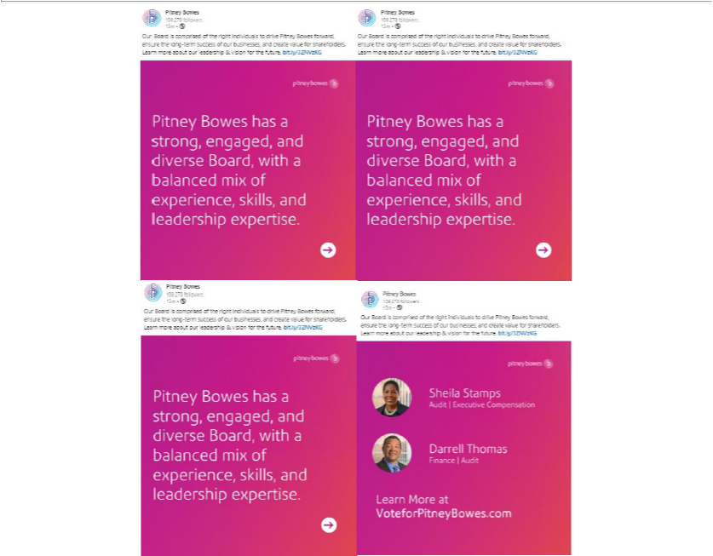

Also in connection with the Annual Meeting, the Company posted the following on Twitter (@PitneyBowes) on April 6, 2023:

Our Board is comprised of the right individuals to drive Pitney Bowes forward, ensure the long-term success of our businesses, and create value for shareholders. Learn more about our leadership & vision for the future.
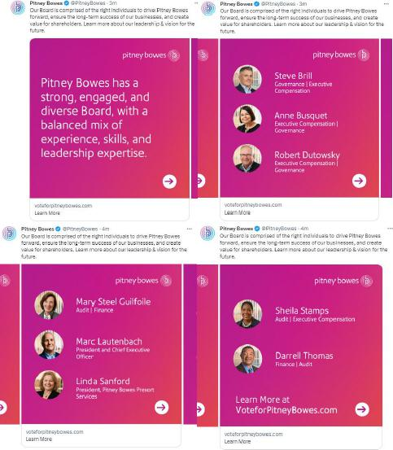

Also on April 6, 2023, the Company made updates to its website in connection with the Annual Meeting (www.voteforpitneybowes.com).

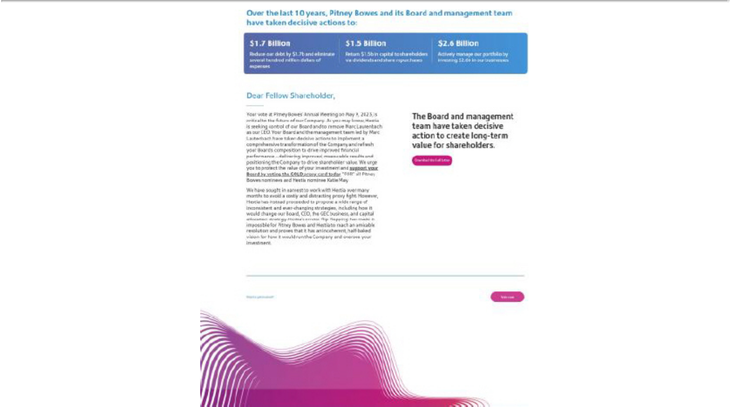

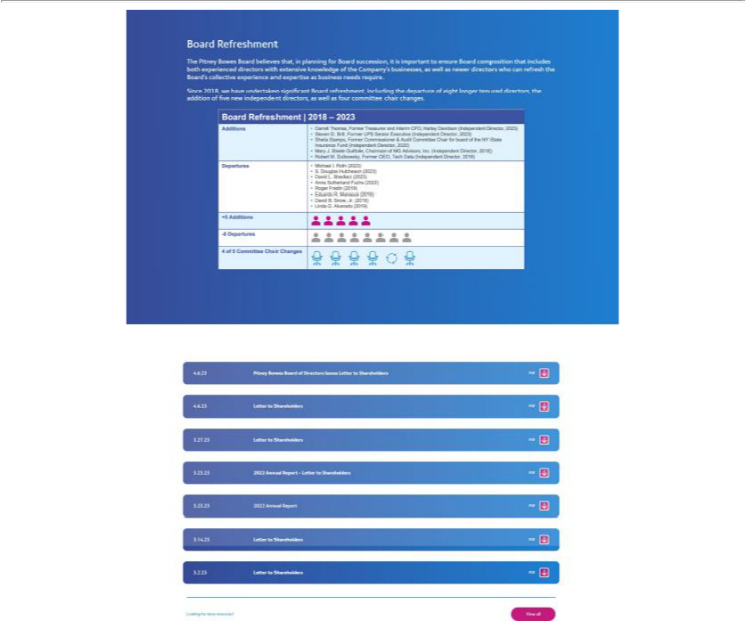

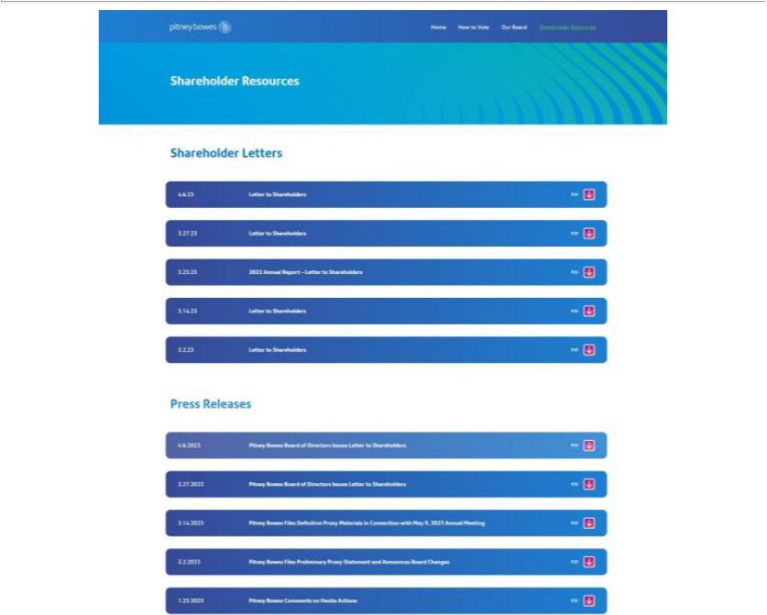

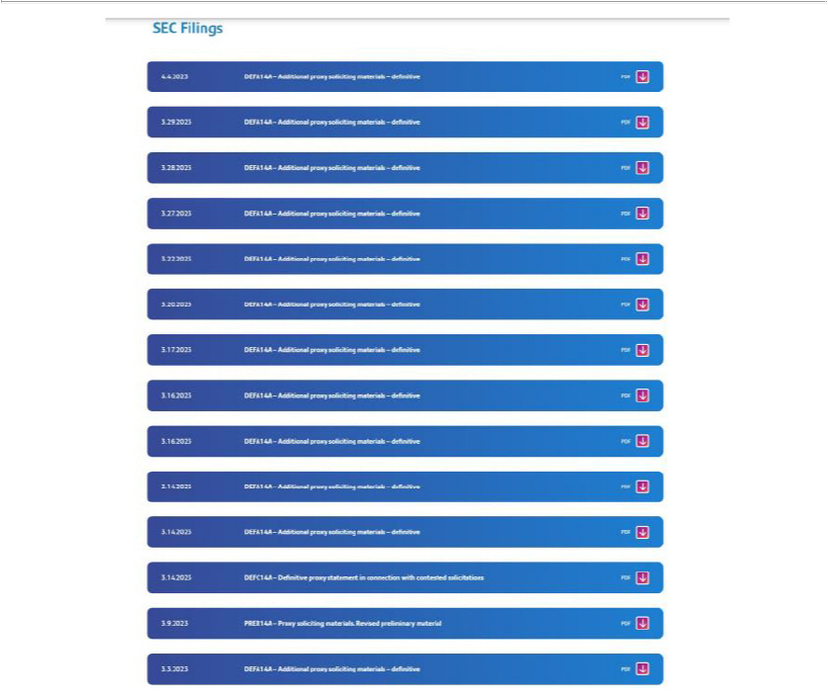



About Pitney Bowes

Pitney Bowes (NYSE: PBI) is a global shipping and mailing company that provides technology, logistics, and financial services to more than 90 percent of the Fortune 500. Small business, retail, enterprise, and government clients around the world rely on Pitney Bowes to remove the complexity of sending mail and parcels. For the latest news, corporate announcements and financial results visit https://www.pitneybowes.com/us/newsroom.html. For additional information visit Pitney Bowes at www.pitneybowes.com.

Forward-Looking Statements

The above materials contain “forward-looking statements” about the Company’s expected or potential future business and financial performance. Forward-looking statements include, but are not limited to, statements about future revenue and earnings guidance and future events or conditions. Forward-looking statements are not guarantees of future performance and involve risks and uncertainties that could cause actual results to differ materially from those projected. In particular, we continue to navigate the impacts of the Covid-19 pandemic (Covid-19) as well as the risk of a global recession, and the effects that they may have on our and our clients’ business. Other factors which could cause future financial performance to differ materially from expectations, and which may also be exacerbated by Covid-19 or the risk of a global recession or a negative change in the economy, include, without limitation, declining physical mail volumes; changes in postal regulations or the operations and financial health of posts in the U.S. or other major markets or changes to the broader postal or shipping markets; the loss of, or significant changes to, United States Postal Service (USPS) commercial programs, or our contractual relationships with the USPS or USPS’ performance under those contracts; our ability to continue to grow and manage volumes, gain additional economies of scale and improve profitability within our Global Ecommerce segment; changes in labor and transportation availability and costs; and other factors as more fully outlined in the Company’s 2022 Form 10-K Annual Report and other reports filed with the Securities and Exchange Commission (the “SEC”). Pitney Bowes assumes no obligation to update any forward-looking statements contained in this document as a result of new information, events or developments.

Important Additional Information and Where to Find It

Pitney Bowes has filed a definitive proxy statement (the “Proxy Statement”) and other documents with the SEC in connection with its solicitation of proxies from shareholders in respect of Pitney Bowes’ 2023 annual meeting of shareholders. BEFORE MAKING ANY VOTING DECISION, INVESTORS AND SECURITY HOLDERS ARE URGED TO READ ALL RELEVANT DOCUMENTS, INCLUDING PITNEY BOWES’ PROXY STATEMENT AND ANY AMENDMENTS AND SUPPLEMENTS THERETO AND THE ACCOMPANYING GOLD PROXY CARD, FILED WITH THE SEC WHEN THEY BECOME AVAILABLE BECAUSE THEY CONTAIN, OR WILL CONTAIN, IMPORTANT INFORMATION ABOUT PITNEY BOWES. Shareholders may obtain free copies of the Proxy Statement and other relevant documents that Pitney Bowes files with the SEC and on Pitney Bowes’ website at http://www.pitneybowes.com or from the SEC’s website at http://www.sec.gov.

