UNITED STATES
SECURITIES AND EXCHANGE COMMISSION
Washington, D.C. 20549

FORM 8-K
Current Report
Pursuant to Section 13 or 15(d) of the Securities
Exchange Act of 1934
May 5, 2026
Date of Report (Date of earliest event reported)
Pitney Bowes Inc.
(Exact name of registrant as specified in its charter)
Delaware |  |  | 1-3579 |  |  | 06-0495050
(State or other jurisdiction of  incorporation or organization) |  |  | (Commission file number) |  |  | (I.R.S. Employer Identification No.)

Address: |  |  | 27 Waterview Drive, |  |  |  |  |  | Shelton, |  |  | Connecticut |  |  | 06484
Telephone Number: |  |  | (203) |  |  | 922-4000
Not Applicable
(Former name or former address, if changed since last report)
Check the appropriate box below if the Form 8-K filing is intended to simultaneously satisfy the filing obligation of the registrant under any of the following provisions (see General Instruction A.2. below):
☐ Written communications pursuant to Rule 425 under the Securities Act (17 CFR 230.425)
☐ Soliciting material pursuant to Rule 14a-12 under the Exchange Act (17 CFR 240.14a-12)
☐ Pre-commencement communications pursuant to Rule 14d-2(b) under the Exchange Act (17 CFR 240.14d-2(b))
☐ Pre-commencement communications pursuant to Rule 13e-4(c) under the Exchange Act (17 CFR 240.13e-4(c))

Securities registered pursuant to Section 12(b) of the Act:
Title of Each Class |  |  |  |  |  | Trading Symbol(s) |  |  |  |  |  | Name of Each Exchange on Which Registered
Common Stock, $1 par value per share |  |  |  |  |  | PBI |  |  |  |  |  | New York Stock Exchange
6.70% Notes due 2043 |  |  |  |  |  | PBI.PRB |  |  |  |  |  | New York Stock Exchange
Indicate by check mark whether the registrant is an emerging growth company as defined in Rule 405 of the Securities Act of 1933 (§230.405 of this chapter) or Rule 12b-2 of the Securities Exchange Act of 1934 (§240.12b-2 of this chapter).
Emerging growth company ☐
If an emerging growth company, indicate by check mark if the registrant has elected not to use the extended transition period for complying with any new or revised financial accounting standards provided pursuant to Section 13(a) of the Securities Act. ☐

ITEM 2.02 RESULTS OF OPERATIONS AND FINANCIAL CONDITION
On May 5, 2026, the Registrant issued a press release setting forth its financial results, including consolidated statements of income, supplemental information, and a reconciliation of reported results to adjusted results for the three months ended March 31, 2026 and 2025, and consolidated balance sheets at March 31, 2026 and December 31, 2025. A copy of the press release is attached hereto as Exhibit 99.1 and hereby incorporated by reference.
In addition, on May 5, 2026, Kurt Wolf, the Company's President and Chief Executive Officer, issued a letter regarding the Company's financial results for the three months ended March 31, 2026. A copy of the letter is attached hereto as Exhibit 99.2 and hereby incorporated by reference.

Forward-Looking Statements
The exhibits contain “forward-looking statements” about the Company’s expected or potential future business and financial performance, including, but not limited to, statements about future revenue and profitability, earnings guidance, future events or conditions, capital allocation strategy, expected cost savings and efficiency improvements, and strategic initiatives and priorities. Forward-looking statements are not guarantees of future performance and involve risks and uncertainties that could cause actual results to differ materially from those projected. Factors which could cause future performance to differ materially from expectations include, without limitation, changes in postal regulations or the operations and financial health of posts in the U.S. or other major markets or changes to the broader postal or shipping markets; declines in physical mail volumes or shipping volumes; the loss of customers, including some of our larger clients; changes in trade policies, tariffs and regulations; global supply chain issues adversely impacting our third party suppliers’ ability to provide us products and services; periods of difficult economic conditions, the impacts of inflation and rising prices, higher interest rates and a slow-down in economic activity, including a global recession, or a prolonged U.S. government shutdown, to the Company and our clients; changes in foreign currency exchange rates; changes in labor and transportation availability and costs; inability to successfully execute on our strategic initiatives; and other factors as more fully outlined in the Company's Annual Report on Form 10-K/A for the year ended December 31, 2025 and other reports subsequently filed with the Securities and Exchange Commission. Pitney Bowes assumes no obligation to update any forward-looking statements contained in this document as a result of new information, events, or developments, except as required by law.
ITEM 9.01 FINANCIAL STATEMENTS AND EXHIBITS

(d) Exhibits
99.1 |  |  | Press release of Pitney Bowes Inc. dated May 5, 2026.
99.2 |  |  | Letter from Kurt Wolf regarding First Quarter 2026 Financial Results
104 |  |  | The cover page of Pitney Bowes Inc.'s Current Report on Form 8-K, formatted in Inline XBRL.

SIGNATURES
Pursuant to the requirements of the Securities Exchange Act of 1934, as amended, the registrant has duly caused this report to be signed on its behalf by the undersigned hereunto duly authorized.

 |  |  | Pitney Bowes Inc.
 |  |  | By: |  |  | /s/ Kurt Wolf
 |  |  | Name: Kurt Wolf
Date: May 5, 2026 |  |  | Title: Chief Executive Officer

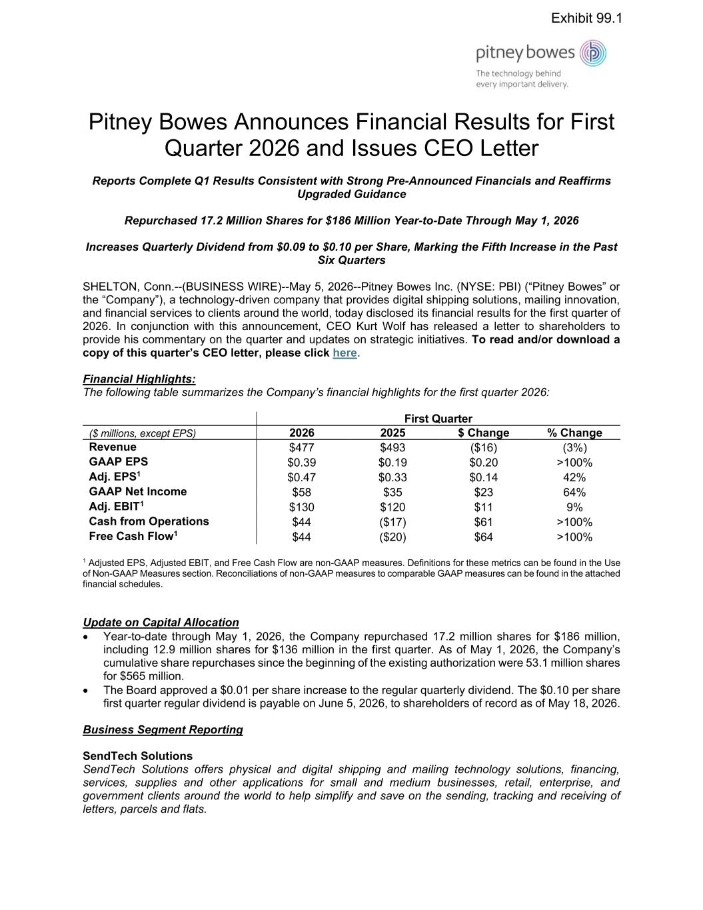

Pitney Bowes Announces Financial Results for First Quarter 2026 and Issues CEO Letter Reports Complete Q1 Results Consistent with Strong Pre-Announced Financials and Reaffirms Upgraded Guidance Repurchased 17.2 Million Shares for $186 Million Year-to-Date Through May 1, 2026 Increases Quarterly Dividend from $0.09 to $0.10 per Share, Marking the Fifth Increase in the Past Six Quarters SHELTON, Conn.--(BUSINESS WIRE)--May 5, 2026--Pitney Bowes Inc. (NYSE: PBI) (“Pitney Bowes” or the “Company”), a technology-driven company that provides digital shipping solutions, mailing innovation, and financial services to clients around the world, today disclosed its financial results for the first quarter of 2026. In conjunction with this announcement, CEO Kurt Wolf has released a letter to shareholders to provide his commentary on the quarter and updates on strategic initiatives. To read and/or download a copy of this quarter’s CEO letter, please click here. Financial Highlights: The following table summarizes the Company’s financial highlights for the first quarter 2026: First Quarter ($ millions, except EPS) 2026 2025 $ Change % Change Revenue $477 $493 ($16) (3%) GAAP EPS $0.39 $0.19 $0.20 >100% Adj. EPS1 $0.47 $0.33 $0.14 42% GAAP Net Income $58 $35 $23 64% Adj. EBIT1 $130 $120 $11 9% Cash from Operations $44 ($17) $61 >100% Free Cash Flow1 $44 ($20) $64 >100% 1 Adjusted EPS, Adjusted EBIT, and Free Cash Flow are non-GAAP measures. Definitions for these metrics can be found in the Use of Non-GAAP Measures section. Reconciliations of non-GAAP measures to comparable GAAP measures can be found in the attached financial schedules. Update on Capital Allocation • Year-to-date through May 1, 2026, the Company repurchased 17.2 million shares for $186 million, including 12.9 million shares for $136 million in the first quarter. As of May 1, 2026, the Company’s cumulative share repurchases since the beginning of the existing authorization were 53.1 million shares for $565 million. • The Board approved a $0.01 per share increase to the regular quarterly dividend. The $0.10 per share first quarter regular dividend is payable on June 5, 2026, to shareholders of record as of May 18, 2026. Business Segment Reporting SendTech Solutions SendTech Solutions offers physical and digital shipping and mailing technology solutions, financing, services, supplies and other applications for small and medium businesses, retail, enterprise, and government clients around the world to help simplify and save on the sending, tracking and receiving of letters, parcels and flats. Exhibit 99.1

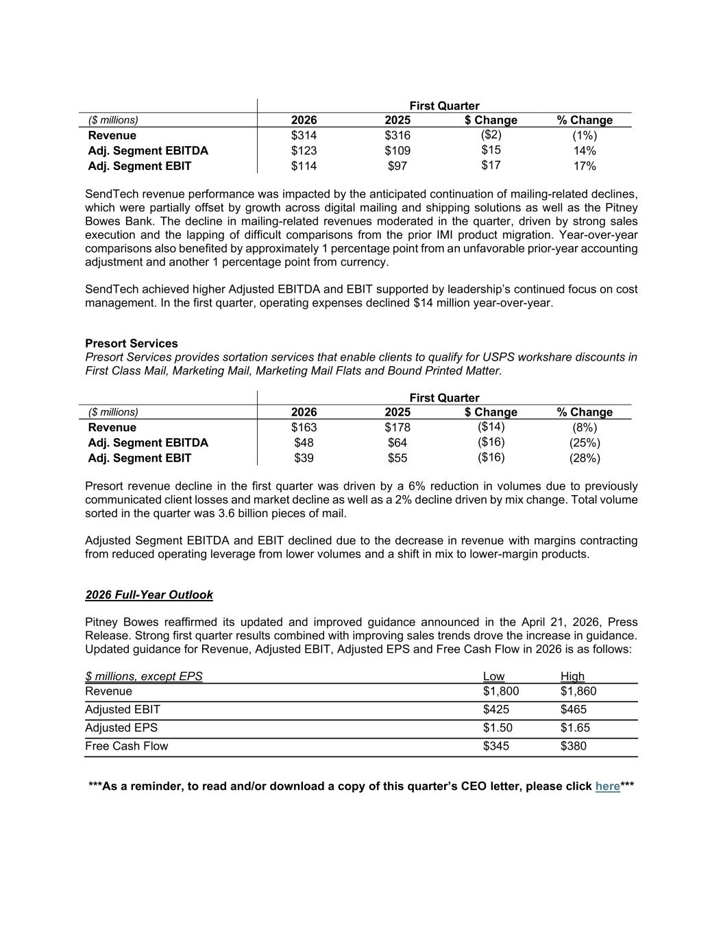
First Quarter ($ millions) 2026 2025 $ Change % Change Revenue $314 $316 ($2) (1%) Adj. Segment EBITDA $123 $109 $15 14% Adj. Segment EBIT $114 $97 $17 17% SendTech revenue performance was impacted by the anticipated continuation of mailing-related declines, which were partially offset by growth across digital mailing and shipping solutions as well as the Pitney Bowes Bank. The decline in mailing-related revenues moderated in the quarter, driven by strong sales execution and the lapping of difficult comparisons from the prior IMI product migration. Year-over-year comparisons also benefited by approximately 1 percentage point from an unfavorable prior-year accounting adjustment and another 1 percentage point from currency. SendTech achieved higher Adjusted EBITDA and EBIT supported by leadership’s continued focus on cost management. In the first quarter, operating expenses declined $14 million year-over-year. Presort Services Presort Services provides sortation services that enable clients to qualify for USPS workshare discounts in First Class Mail, Marketing Mail, Marketing Mail Flats and Bound Printed Matter. First Quarter ($ millions) 2026 2025 $ Change % Change Revenue $163 $178 ($14) (8%) Adj. Segment EBITDA $48 $64 ($16) (25%) Adj. Segment EBIT $39 $55 ($16) (28%) Presort revenue decline in the first quarter was driven by a 6% reduction in volumes due to previously communicated client losses and market decline as well as a 2% decline driven by mix change. Total volume sorted in the quarter was 3.6 billion pieces of mail. Adjusted Segment EBITDA and EBIT declined due to the decrease in revenue with margins contracting from reduced operating leverage from lower volumes and a shift in mix to lower-margin products. 2026 Full-Year Outlook Pitney Bowes reaffirmed its updated and improved guidance announced in the April 21, 2026, Press Release. Strong first quarter results combined with improving sales trends drove the increase in guidance. Updated guidance for Revenue, Adjusted EBIT, Adjusted EPS and Free Cash Flow in 2026 is as follows: $ millions, except EPS Low High Revenue $1,800 $1,860 Adjusted EBIT $425 $465 Adjusted EPS $1.50 $1.65 Free Cash Flow $345 $380 ***As a reminder, to read and/or download a copy of this quarter’s CEO letter, please click here***

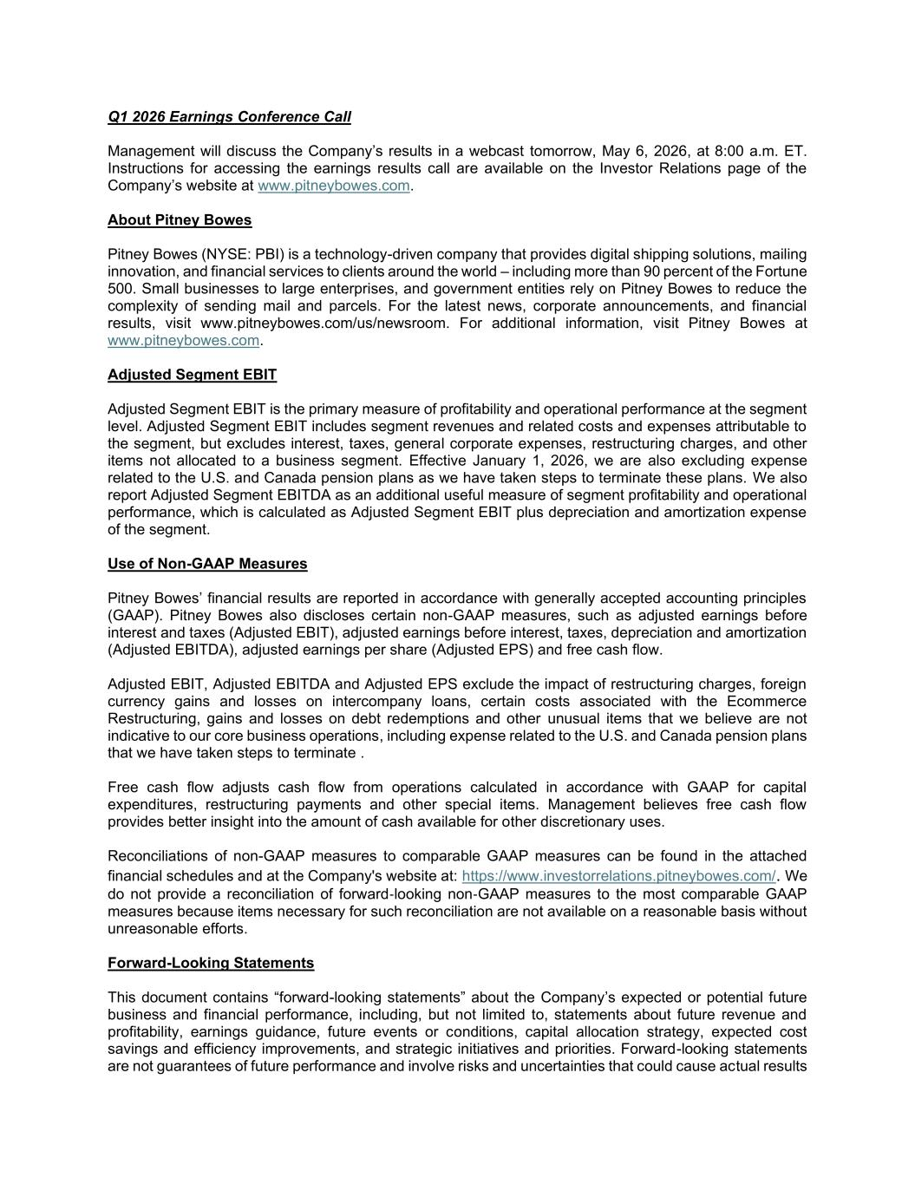
Q1 2026 Earnings Conference Call Management will discuss the Company’s results in a webcast tomorrow, May 6, 2026, at 8:00 a.m. ET. Instructions for accessing the earnings results call are available on the Investor Relations page of the Company’s website at www.pitneybowes.com. About Pitney Bowes Pitney Bowes (NYSE: PBI) is a technology-driven company that provides digital shipping solutions, mailing innovation, and financial services to clients around the world – including more than 90 percent of the Fortune 500. Small businesses to large enterprises, and government entities rely on Pitney Bowes to reduce the complexity of sending mail and parcels. For the latest news, corporate announcements, and financial results, visit www.pitneybowes.com/us/newsroom. For additional information, visit Pitney Bowes at www.pitneybowes.com. Adjusted Segment EBIT Adjusted Segment EBIT is the primary measure of profitability and operational performance at the segment level. Adjusted Segment EBIT includes segment revenues and related costs and expenses attributable to the segment, but excludes interest, taxes, general corporate expenses, restructuring charges, and other items not allocated to a business segment. Effective January 1, 2026, we are also excluding expense related to the U.S. and Canada pension plans as we have taken steps to terminate these plans. We also report Adjusted Segment EBITDA as an additional useful measure of segment profitability and operational performance, which is calculated as Adjusted Segment EBIT plus depreciation and amortization expense of the segment. Use of Non-GAAP Measures Pitney Bowes’ financial results are reported in accordance with generally accepted accounting principles (GAAP). Pitney Bowes also discloses certain non-GAAP measures, such as adjusted earnings before interest and taxes (Adjusted EBIT), adjusted earnings before interest, taxes, depreciation and amortization (Adjusted EBITDA), adjusted earnings per share (Adjusted EPS) and free cash flow. Adjusted EBIT, Adjusted EBITDA and Adjusted EPS exclude the impact of restructuring charges, foreign currency gains and losses on intercompany loans, certain costs associated with the Ecommerce Restructuring, gains and losses on debt redemptions and other unusual items that we believe are not indicative to our core business operations, including expense related to the U.S. and Canada pension plans that we have taken steps to terminate . Free cash flow adjusts cash flow from operations calculated in accordance with GAAP for capital expenditures, restructuring payments and other special items. Management believes free cash flow provides better insight into the amount of cash available for other discretionary uses. Reconciliations of non-GAAP measures to comparable GAAP measures can be found in the attached financial schedules and at the Company's website at: https://www.investorrelations.pitneybowes.com/. We do not provide a reconciliation of forward-looking non-GAAP measures to the most comparable GAAP measures because items necessary for such reconciliation are not available on a reasonable basis without unreasonable efforts. Forward-Looking Statements This document contains “forward-looking statements” about the Company’s expected or potential future business and financial performance, including, but not limited to, statements about future revenue and profitability, earnings guidance, future events or conditions, capital allocation strategy, expected cost savings and efficiency improvements, and strategic initiatives and priorities. Forward-looking statements are not guarantees of future performance and involve risks and uncertainties that could cause actual results

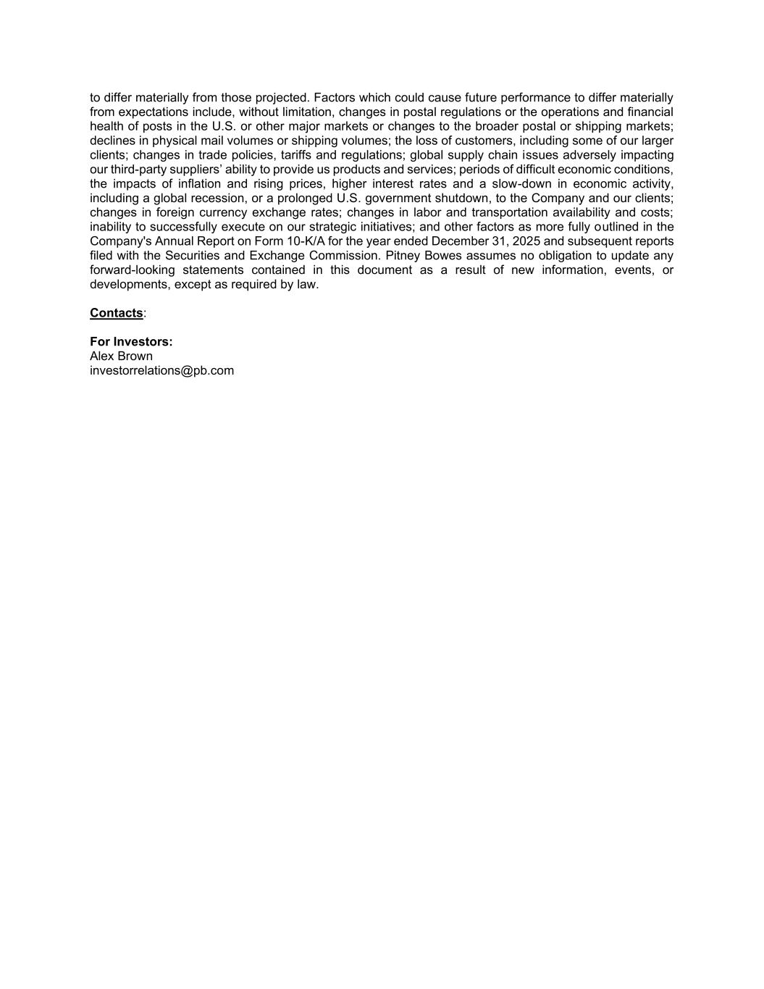
to differ materially from those projected. Factors which could cause future performance to differ materially from expectations include, without limitation, changes in postal regulations or the operations and financial health of posts in the U.S. or other major markets or changes to the broader postal or shipping markets; declines in physical mail volumes or shipping volumes; the loss of customers, including some of our larger clients; changes in trade policies, tariffs and regulations; global supply chain issues adversely impacting our third-party suppliers’ ability to provide us products and services; periods of difficult economic conditions, the impacts of inflation and rising prices, higher interest rates and a slow-down in economic activity, including a global recession, or a prolonged U.S. government shutdown, to the Company and our clients; changes in foreign currency exchange rates; changes in labor and transportation availability and costs; inability to successfully execute on our strategic initiatives; and other factors as more fully outlined in the Company's Annual Report on Form 10-K/A for the year ended December 31, 2025 and subsequent reports filed with the Securities and Exchange Commission. Pitney Bowes assumes no obligation to update any forward-looking statements contained in this document as a result of new information, events, or developments, except as required by law. Contacts: For Investors: Alex Brown investorrelations@pb.com

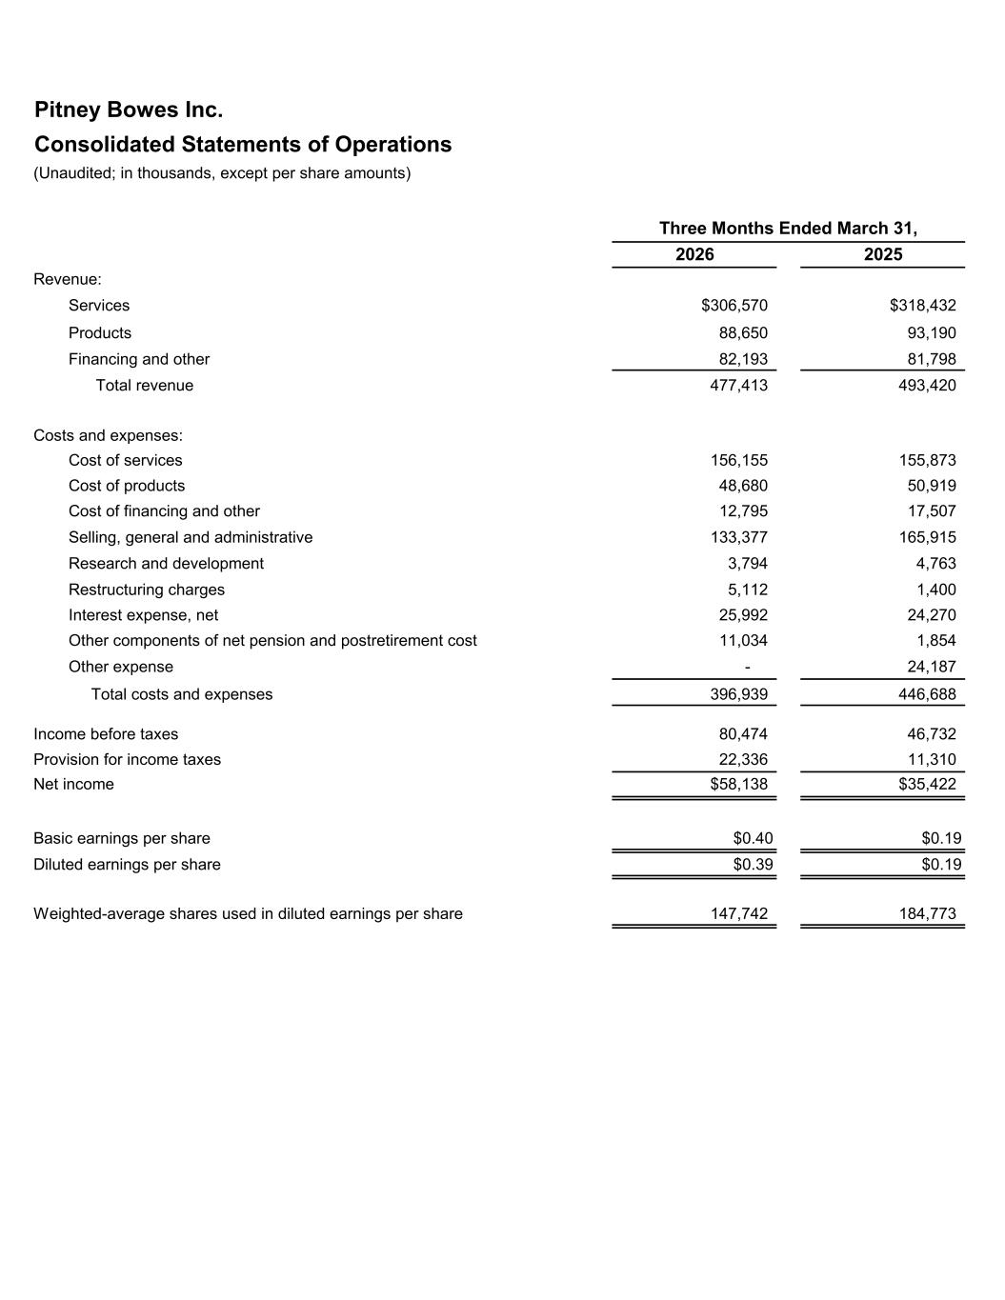
Pitney Bowes Inc. Consolidated Statements of Operations (Unaudited; in thousands, except per share amounts) 2026 2025 Revenue: Services $306,570 $318,432 Products 88,650 93,190 Financing and other 82,193 81,798 Total revenue 477,413 493,420 Costs and expenses: Cost of services 156,155 155,873 Cost of products 48,680 50,919 Cost of financing and other 12,795 17,507 Selling, general and administrative 133,377 165,915 Research and development 3,794 4,763 Restructuring charges 5,112 1,400 Interest expense, net 25,992 24,270 Other components of net pension and postretirement cost 11,034 1,854 Other expense - 24,187 Total costs and expenses 396,939 446,688 Income before taxes 80,474 46,732 Provision for income taxes 22,336 11,310 Net income $58,138 $35,422 Basic earnings per share $0.40 $0.19 Diluted earnings per share $0.39 $0.19 Weighted-average shares used in diluted earnings per share 147,742 184,773 Three Months Ended March 31,

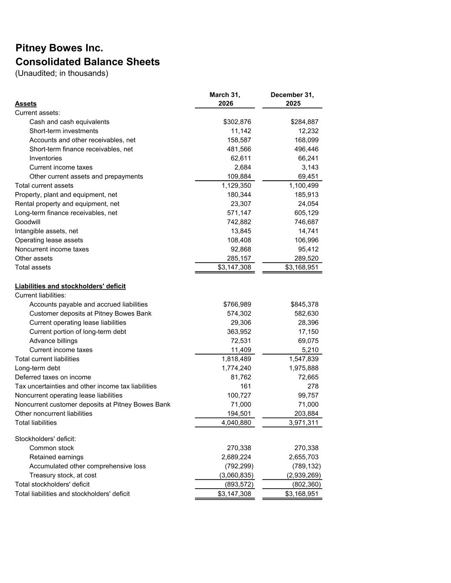
Pitney Bowes Inc. Consolidated Balance Sheets (Unaudited; in thousands) Assets March 31, 2026 December 31, 2025 Current assets: Cash and cash equivalents $302,876 $284,887 Short-term investments 11,142 12,232 Accounts and other receivables, net 158,587 168,099 Short-term finance receivables, net 481,566 496,446 Inventories 62,611 66,241 Current income taxes 2,684 3,143 Other current assets and prepayments 109,884 69,451 Total current assets 1,129,350 1,100,499 Property, plant and equipment, net 180,344 185,913 Rental property and equipment, net 23,307 24,054 Long-term finance receivables, net 571,147 605,129 Goodwill 742,882 746,687 Intangible assets, net 13,845 14,741 Operating lease assets 108,408 106,996 Noncurrent income taxes 92,868 95,412 Other assets 285,157 289,520 Total assets $3,147,308 $3,168,951 Liabilities and stockholders' deficit Current liabilities: Accounts payable and accrued liabilities $766,989 $845,378 Customer deposits at Pitney Bowes Bank 574,302 582,630 Current operating lease liabilities 29,306 28,396 Current portion of long-term debt 363,952 17,150 Advance billings 72,531 69,075 Current income taxes 11,409 5,210 Total current liabilities 1,818,489 1,547,839 Long-term debt 1,774,240 1,975,888 Deferred taxes on income 81,762 72,665 Tax uncertainties and other income tax liabilities 161 278 Noncurrent operating lease liabilities 100,727 99,757 Noncurrent customer deposits at Pitney Bowes Bank 71,000 71,000 Other noncurrent liabilities 194,501 203,884 Total liabilities 4,040,880 3,971,311 Stockholders' deficit: Common stock 270,338 270,338 Retained earnings 2,689,224 2,655,703 Accumulated other comprehensive loss (792,299) (789,132) Treasury stock, at cost (3,060,835) (2,939,269) Total stockholders' deficit (893,572) (802,360) Total liabilities and stockholders' deficit $3,147,308 $3,168,951

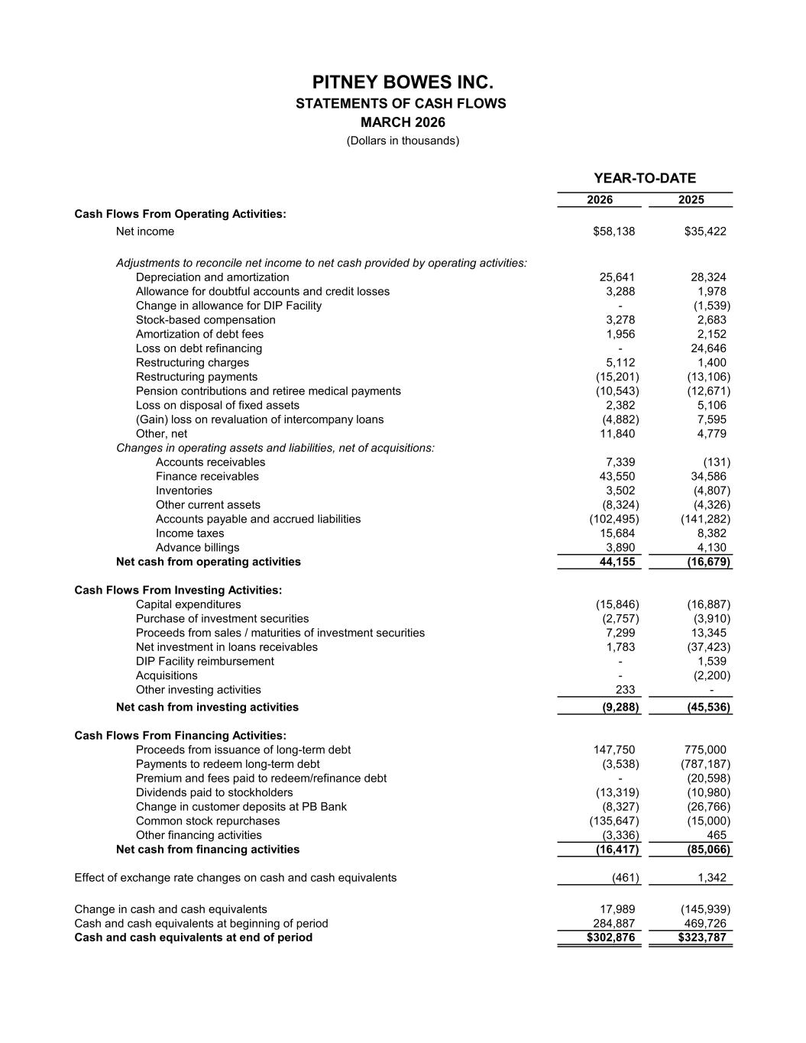
2026 2025 Cash Flows From Operating Activities: Net income $58,138 $35,422 Adjustments to reconcile net income to net cash provided by operating activities: Depreciation and amortization 25,641 28,324 Allowance for doubtful accounts and credit losses 3,288 1,978 Change in allowance for DIP Facility - (1,539) Stock-based compensation 3,278 2,683 Amortization of debt fees 1,956 2,152 Loss on debt refinancing - 24,646 Restructuring charges 5,112 1,400 Restructuring payments (15,201) (13,106) Pension contributions and retiree medical payments (10,543) (12,671) Loss on disposal of fixed assets 2,382 5,106 (Gain) loss on revaluation of intercompany loans (4,882) 7,595 Other, net 11,840 4,779 Changes in operating assets and liabilities, net of acquisitions: Accounts receivables 7,339 (131) Finance receivables 43,550 34,586 Inventories 3,502 (4,807) Other current assets (8,324) (4,326) Accounts payable and accrued liabilities (102,495) (141,282) Income taxes 15,684 8,382 Advance billings 3,890 4,130 Net cash from operating activities 44,155 (16,679) Cash Flows From Investing Activities: Capital expenditures (15,846) (16,887) Purchase of investment securities (2,757) (3,910) Proceeds from sales / maturities of investment securities 7,299 13,345 Net investment in loans receivables 1,783 (37,423) DIP Facility reimbursement - 1,539 Acquisitions - (2,200) Other investing activities 233 - Net cash from investing activities (9,288) (45,536) Cash Flows From Financing Activities: Proceeds from issuance of long-term debt 147,750 775,000 Payments to redeem long-term debt (3,538) (787,187) Premium and fees paid to redeem/refinance debt - (20,598) Dividends paid to stockholders (13,319) (10,980) Change in customer deposits at PB Bank (8,327) (26,766) Common stock repurchases (135,647) (15,000) Other financing activities (3,336) 465 Net cash from financing activities (16,417) (85,066) Effect of exchange rate changes on cash and cash equivalents (461) 1,342 Change in cash and cash equivalents 17,989 (145,939) Cash and cash equivalents at beginning of period 284,887 469,726 Cash and cash equivalents at end of period $302,876 $323,787 YEAR-TO-DATE MARCH 2026 (Dollars in thousands) PITNEY BOWES INC. STATEMENTS OF CASH FLOWS

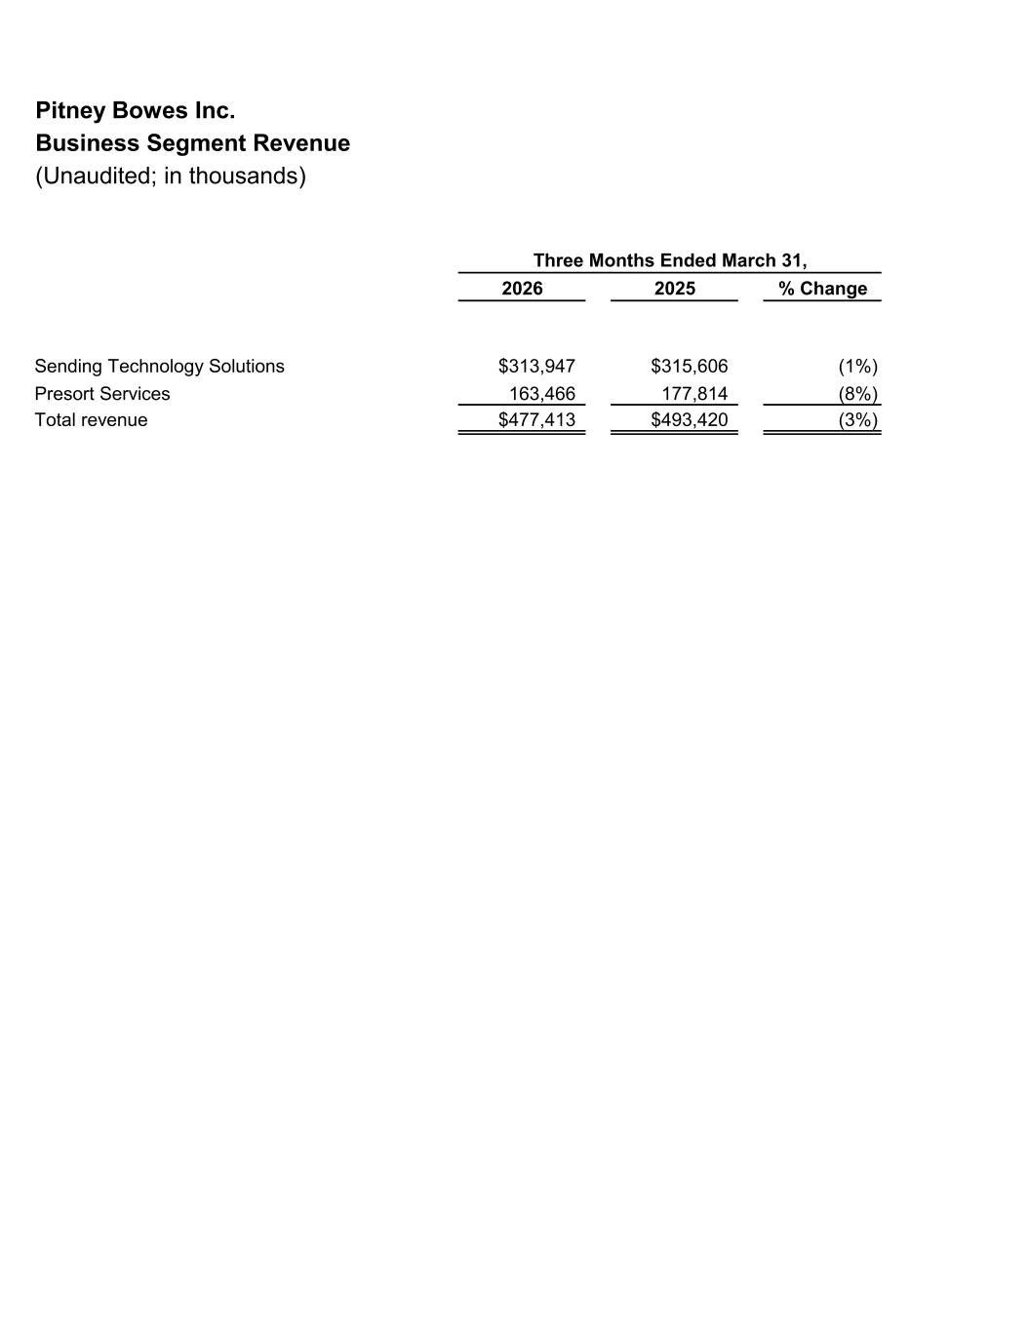
Pitney Bowes Inc. Business Segment Revenue (Unaudited; in thousands) 2026 2025 % Change Sending Technology Solutions $313,947 $315,606 (1%) Presort Services 163,466 177,814 (8%) Total revenue $477,413 $493,420 (3%) Three Months Ended March 31,

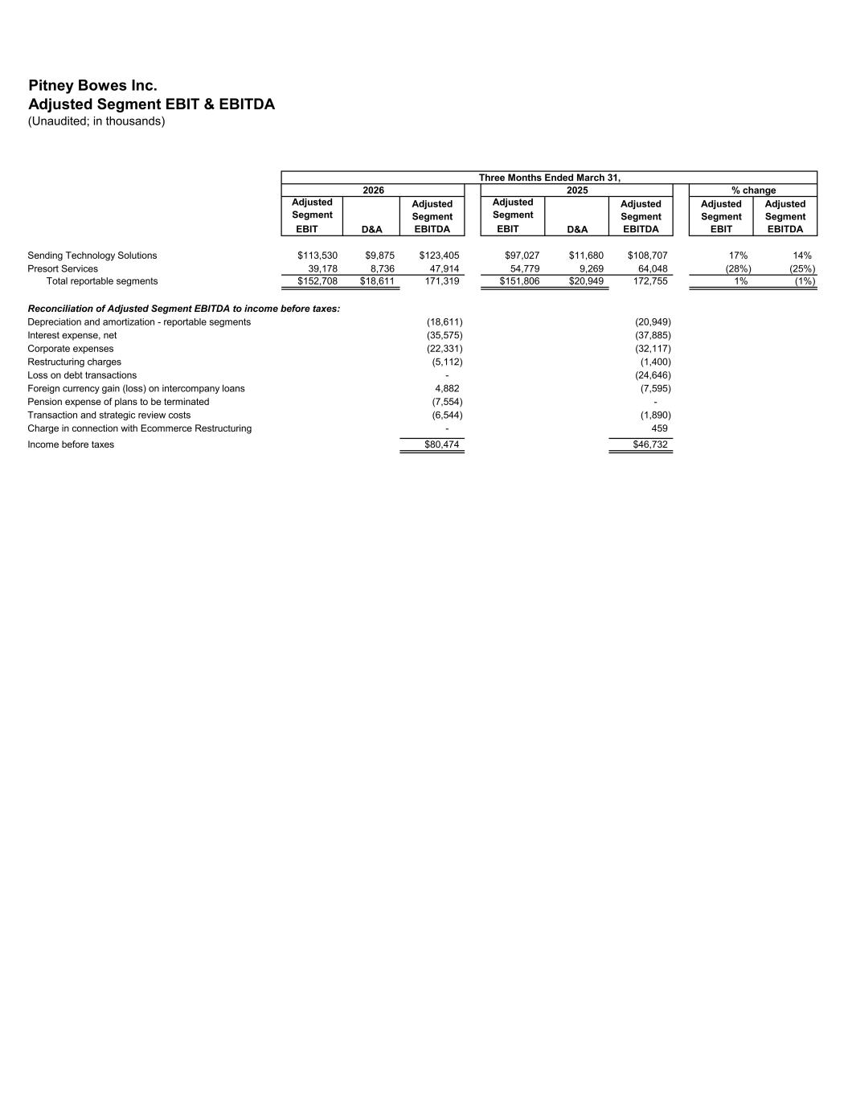
Pitney Bowes Inc. Adjusted Segment EBIT & EBITDA (Unaudited; in thousands) Adjusted Segment EBIT D&A Adjusted Segment EBITDA Adjusted Segment EBIT D&A Adjusted Segment EBITDA Adjusted Segment EBIT Adjusted Segment EBITDA Sending Technology Solutions $113,530 $9,875 $123,405 $97,027 $11,680 $108,707 17% 14% Presort Services 39,178 8,736 47,914 54,779 9,269 64,048 (28%) (25%) Total reportable segments $152,708 $18,611 171,319 $151,806 $20,949 172,755 1% (1%) Reconciliation of Adjusted Segment EBITDA to income before taxes: Depreciation and amortization - reportable segments (18,611) (20,949) Interest expense, net (35,575) (37,885) Corporate expenses (22,331) (32,117) Restructuring charges (5,112) (1,400) Loss on debt transactions - (24,646) Foreign currency gain (loss) on intercompany loans 4,882 (7,595) Pension expense of plans to be terminated (7,554) - Transaction and strategic review costs (6,544) (1,890) Charge in connection with Ecommerce Restructuring - 459 Income before taxes $80,474 $46,732 Three Months Ended March 31, 2026 2025 % change

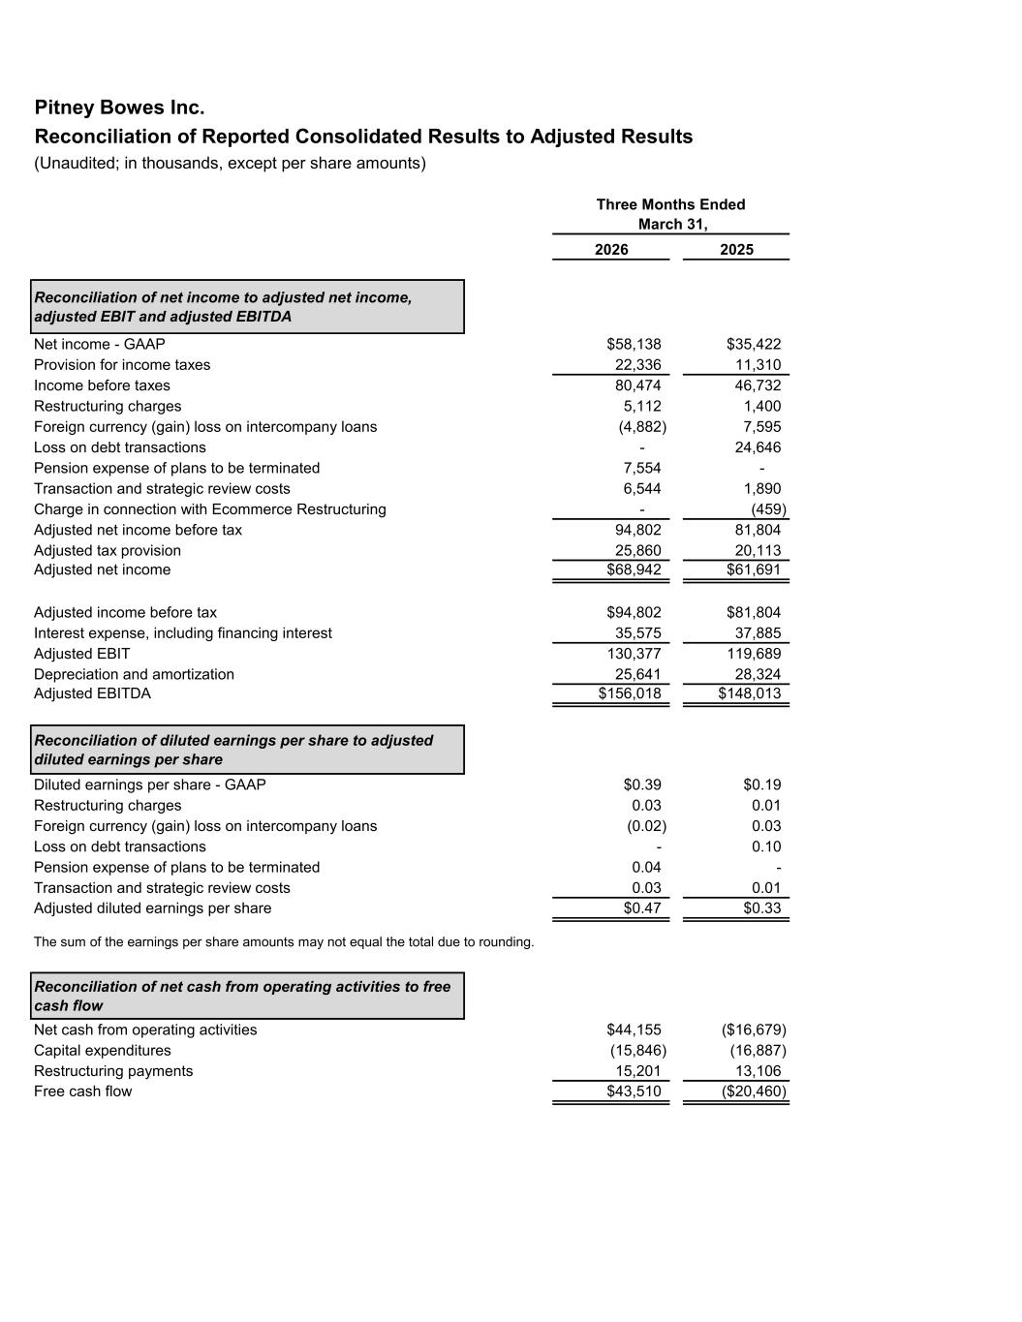
Pitney Bowes Inc. Reconciliation of Reported Consolidated Results to Adjusted Results (Unaudited; in thousands, except per share amounts) 2026 2025 Reconciliation of net income to adjusted net income, adjusted EBIT and adjusted EBITDA Net income - GAAP $58,138 $35,422 Provision for income taxes 22,336 11,310 Income before taxes 80,474 46,732 Restructuring charges 5,112 1,400 Foreign currency (gain) loss on intercompany loans (4,882) 7,595 Loss on debt transactions - 24,646 Pension expense of plans to be terminated 7,554 - Transaction and strategic review costs 6,544 1,890 Charge in connection with Ecommerce Restructuring - (459) Adjusted net income before tax 94,802 81,804 Adjusted tax provision 25,860 20,113 Adjusted net income $68,942 $61,691 Adjusted income before tax $94,802 $81,804 Interest expense, including financing interest 35,575 37,885 Adjusted EBIT 130,377 119,689 Depreciation and amortization 25,641 28,324 Adjusted EBITDA $156,018 $148,013 Reconciliation of diluted earnings per share to adjusted diluted earnings per share Diluted earnings per share - GAAP $0.39 $0.19 Restructuring charges 0.03 0.01 Foreign currency (gain) loss on intercompany loans (0.02) 0.03 Loss on debt transactions - 0.10 Pension expense of plans to be terminated 0.04 - Transaction and strategic review costs 0.03 0.01 Adjusted diluted earnings per share $0.47 $0.33 The sum of the earnings per share amounts may not equal the total due to rounding. Reconciliation of net cash from operating activities to free cash flow Net cash from operating activities $44,155 ($16,679) Capital expenditures (15,846) (16,887) Restructuring payments 15,201 13,106 Free cash flow $43,510 ($20,460) Three Months Ended March 31,

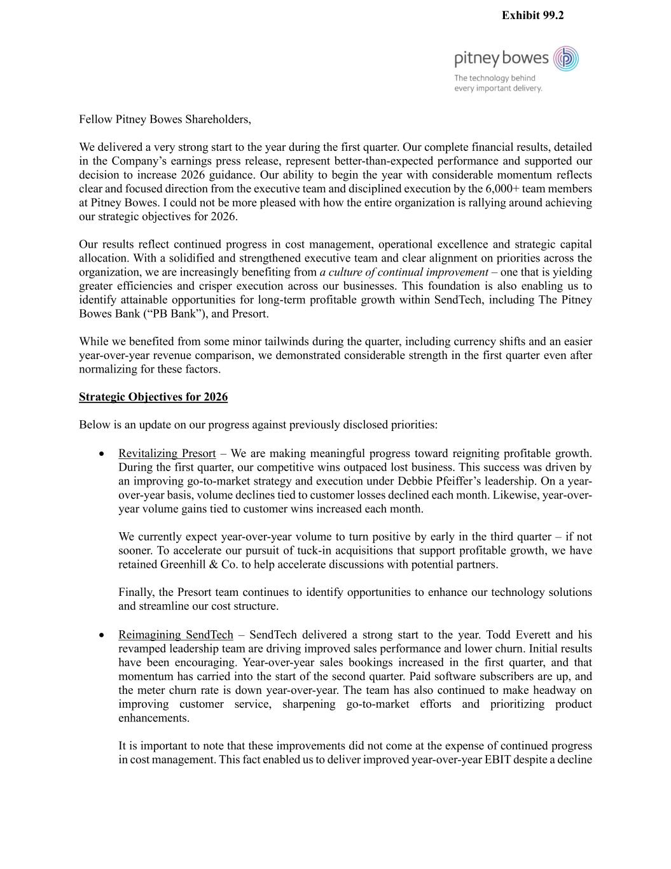
Fellow Pitney Bowes Shareholders, We delivered a very strong start to the year during the first quarter. Our complete financial results, detailed in the Company’s earnings press release, represent better-than-expected performance and supported our decision to increase 2026 guidance. Our ability to begin the year with considerable momentum reflects clear and focused direction from the executive team and disciplined execution by the 6,000+ team members at Pitney Bowes. I could not be more pleased with how the entire organization is rallying around achieving our strategic objectives for 2026. Our results reflect continued progress in cost management, operational excellence and strategic capital allocation. With a solidified and strengthened executive team and clear alignment on priorities across the organization, we are increasingly benefiting from a culture of continual improvement – one that is yielding greater efficiencies and crisper execution across our businesses. This foundation is also enabling us to identify attainable opportunities for long-term profitable growth within SendTech, including The Pitney Bowes Bank (“PB Bank”), and Presort. While we benefited from some minor tailwinds during the quarter, including currency shifts and an easier year-over-year revenue comparison, we demonstrated considerable strength in the first quarter even after normalizing for these factors. Strategic Objectives for 2026 Below is an update on our progress against previously disclosed priorities: • Revitalizing Presort – We are making meaningful progress toward reigniting profitable growth. During the first quarter, our competitive wins outpaced lost business. This success was driven by an improving go-to-market strategy and execution under Debbie Pfeiffer’s leadership. On a year- over-year basis, volume declines tied to customer losses declined each month. Likewise, year-over- year volume gains tied to customer wins increased each month. We currently expect year-over-year volume to turn positive by early in the third quarter – if not sooner. To accelerate our pursuit of tuck-in acquisitions that support profitable growth, we have retained Greenhill & Co. to help accelerate discussions with potential partners. Finally, the Presort team continues to identify opportunities to enhance our technology solutions and streamline our cost structure. ______________________________________________________ • Reimagining SendTech – SendTech delivered a strong start to the year. Todd Everett and his revamped leadership team are driving improved sales performance and lower churn. Initial results have been encouraging. Year-over-year sales bookings increased in the first quarter, and that momentum has carried into the start of the second quarter. Paid software subscribers are up, and the meter churn rate is down year-over-year. The team has also continued to make headway on improving customer service, sharpening go-to-market efforts and prioritizing product enhancements. It is important to note that these improvements did not come at the expense of continued progress in cost management. This fact enabled us to deliver improved year-over-year EBIT despite a decline Exhibit 99.2

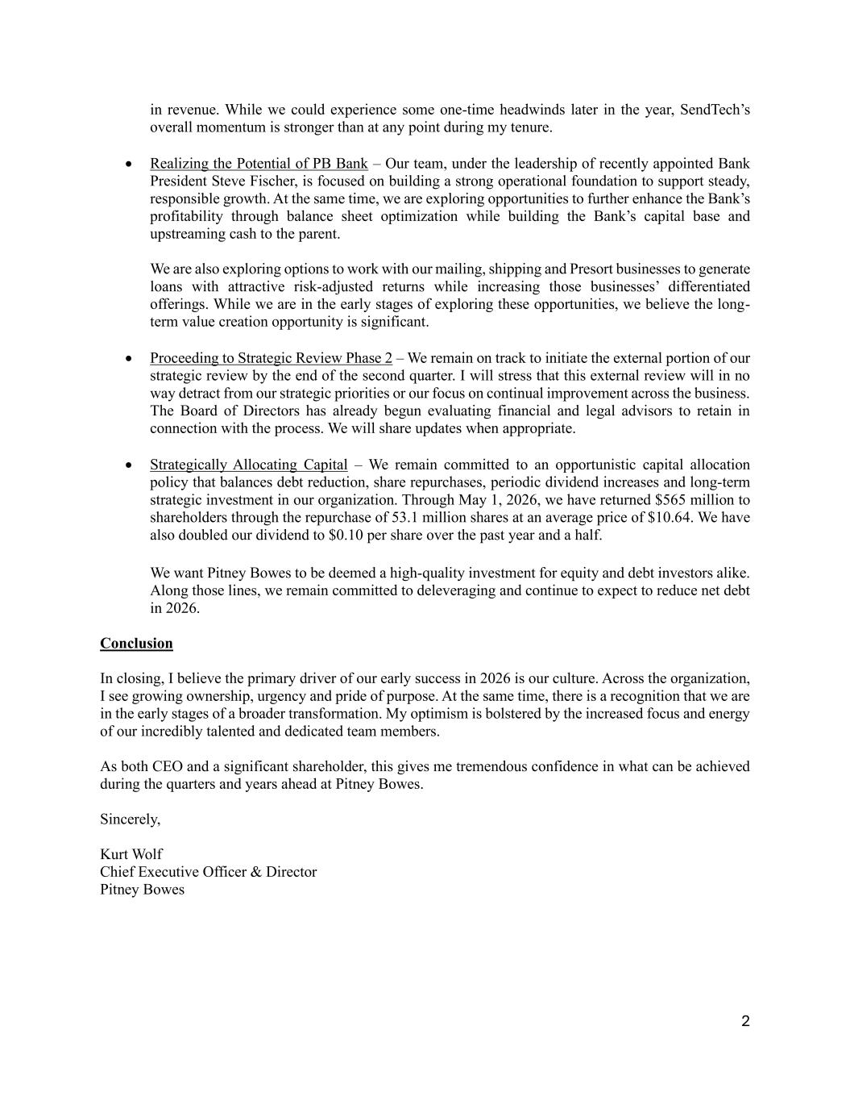
2 in revenue. While we could experience some one-time headwinds later in the year, SendTech’s overall momentum is stronger than at any point during my tenure. • Realizing the Potential of PB Bank – Our team, under the leadership of recently appointed Bank President Steve Fischer, is focused on building a strong operational foundation to support steady, responsible growth. At the same time, we are exploring opportunities to further enhance the Bank’s profitability through balance sheet optimization while building the Bank’s capital base and upstreaming cash to the parent. We are also exploring options to work with our mailing, shipping and Presort businesses to generate loans with attractive risk-adjusted returns while increasing those businesses’ differentiated offerings. While we are in the early stages of exploring these opportunities, we believe the long- term value creation opportunity is significant. • Proceeding to Strategic Review Phase 2 – We remain on track to initiate the external portion of our strategic review by the end of the second quarter. I will stress that this external review will in no way detract from our strategic priorities or our focus on continual improvement across the business. The Board of Directors has already begun evaluating financial and legal advisors to retain in connection with the process. We will share updates when appropriate. • Strategically Allocating Capital – We remain committed to an opportunistic capital allocation policy that balances debt reduction, share repurchases, periodic dividend increases and long-term strategic investment in our organization. Through May 1, 2026, we have returned $565 million to shareholders through the repurchase of 53.1 million shares at an average price of $10.64. We have also doubled our dividend to $0.10 per share over the past year and a half. We want Pitney Bowes to be deemed a high-quality investment for equity and debt investors alike. Along those lines, we remain committed to deleveraging and continue to expect to reduce net debt in 2026. Conclusion In closing, I believe the primary driver of our early success in 2026 is our culture. Across the organization, I see growing ownership, urgency and pride of purpose. At the same time, there is a recognition that we are in the early stages of a broader transformation. My optimism is bolstered by the increased focus and energy of our incredibly talented and dedicated team members. As both CEO and a significant shareholder, this gives me tremendous confidence in what can be achieved during the quarters and years ahead at Pitney Bowes. Sincerely, Kurt Wolf Chief Executive Officer & Director Pitney Bowes

